**Web Design Guide**

**- / -**

Version 1



Introduction - **Design Principles**

**Key Principles:**

* **Hierarchy**: Organize elements so users see what’s most important first.
* **Alignment**: Use grids and consistent spacing to keep things orderly.
* **Contrast**: Create emphasis and visual interest using color, size, or font weight.
* **Proximity**: Group related elements closer together.
* **Balance**: Distribute elements evenly — can be symmetrical or asymmetrical.
* **Repetition**: Reuse consistent styles (buttons, fonts) to reinforce familiarity.
* **Whitespace**: Let elements breathe, improves readability

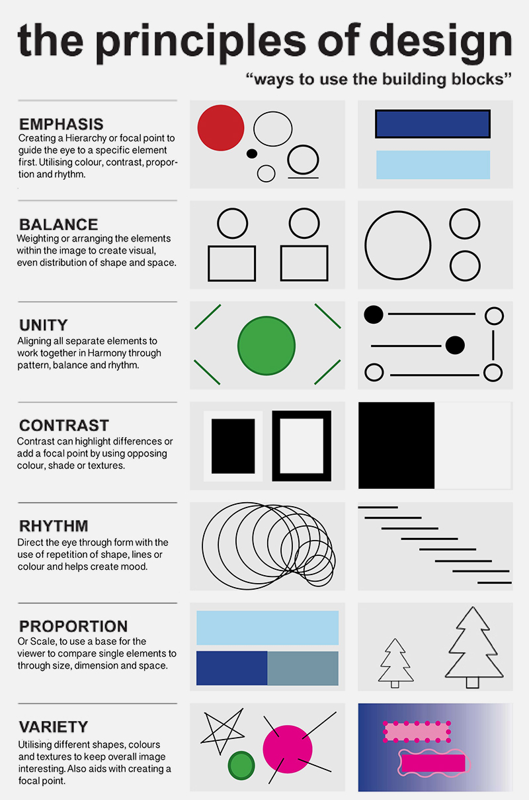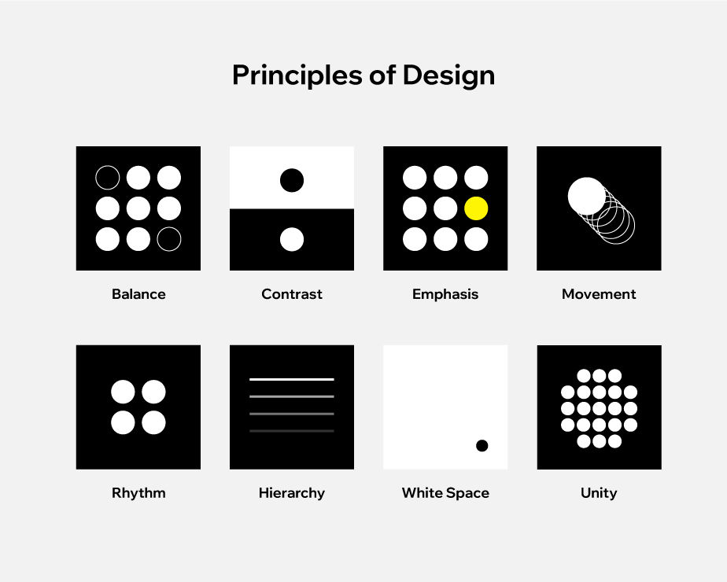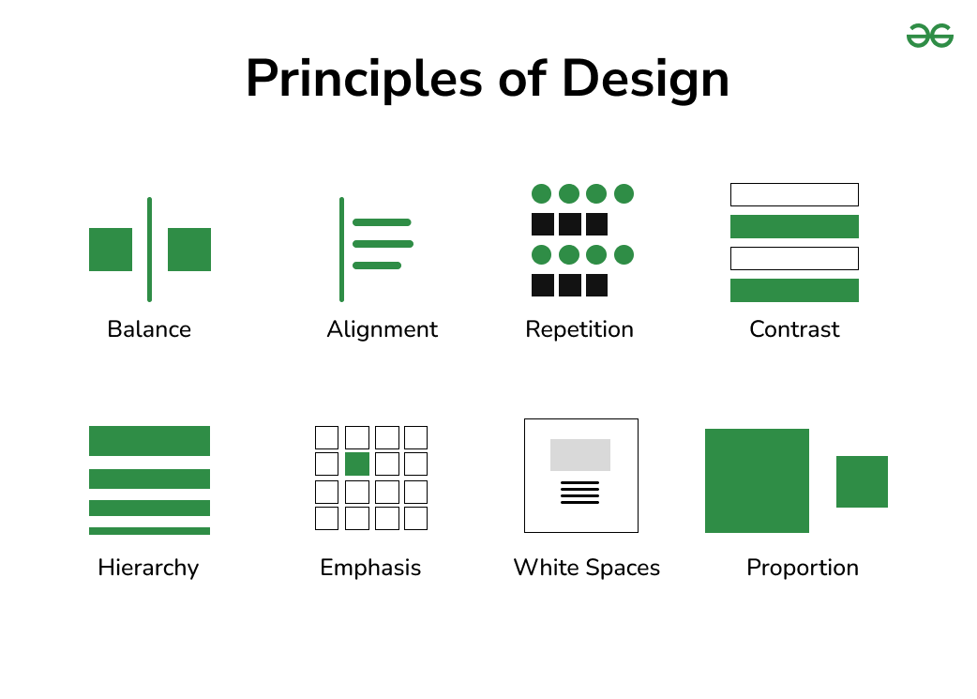

Introduction – **Visual Hierarchy**

**Core Techniques:**

* **Size:** Larger elements attract more attention (e.g., headings vs. body text)
* **Color & Contrast:** Use bold colors/high contrast to emphasize important elements
* **Typography:** Different font weights, styles, and sizes create layers of importance
* **Whitespace:** Space around elements isolates and groups content logically
* **Position:** Elements placed higher or more central in the layout are noticed first
* **Alignment:** Consistent alignment creates order and clarity
* **Repetition:** Repeated styles (colors, shapes) reinforce grouping and flow
* **Shape & Texture:** Unique shapes or textures can highlight or separate elements
* **Motion:** Animation or microinteractions draw attention when used sparingly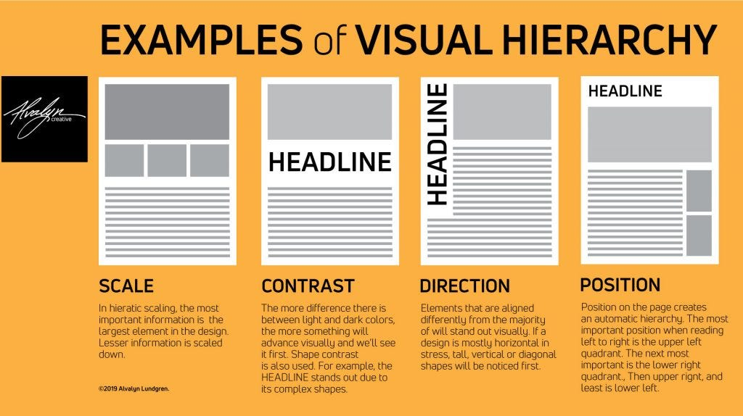

Introduction – **Color Theory**

**Key Concepts:**

* **Primary Colors**: Red, Blue, Yellow (base colors)
* **Secondary Colors**: Orange, Green, Purple (made by mixing primaries)
* **Tertiary Colors**: Mix of primary + secondary (e.g., teal, magenta)

**Color Harmonies:**

* **Monochromatic:** Variations of one hue (light/dark).
* **Analogous:** Colors next to each other on the wheel (e.g., Blue, Teal, Green).
* **Complementary:** Opposite colors (e.g., Blue & Orange) for high contrast.
* **Split-Complementary:**Base color + 2 neighbors of its complement, less tension than complementary.
* **Triadic:** Three evenly spaced colors (e.g., Red, Yellow, Blue).
* **Tetradic (Double Complementary):**   
  Two complementary pairs (rich, diverse palette).
* **Square:** Four evenly spaced colors around the wheel.

**Practical Tips:**

* Use **1 primary color**, **1–2 secondary colors**, and plenty of **neutral tones**
* Reserve bold or contrasting colors for **CTA buttons and alerts**
* Test your palette for **color blindness and accessibility**

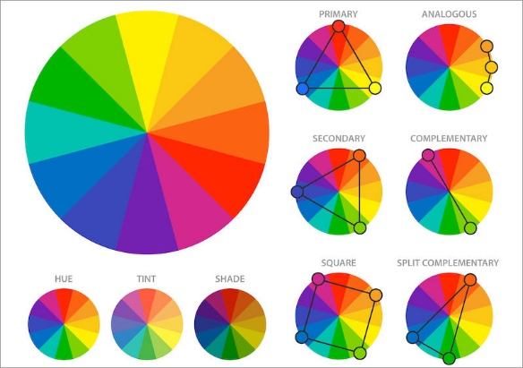

Extended Introduction – **Color Theory**

### **Color Psychology:**

* **Red:** Energy, passion, urgency
* **Orange:** Creativity, friendliness, enthusiasm
* **Yellow:** Optimism, warmth, attention
* **Green:** Growth, health, calm
* **Blue:** Trust, professionalism, calm
* **Purple:** Luxury, creativity, wisdom
* **Black:** Power, sophistication, formality
* **White:** Cleanliness, simplicity, purity

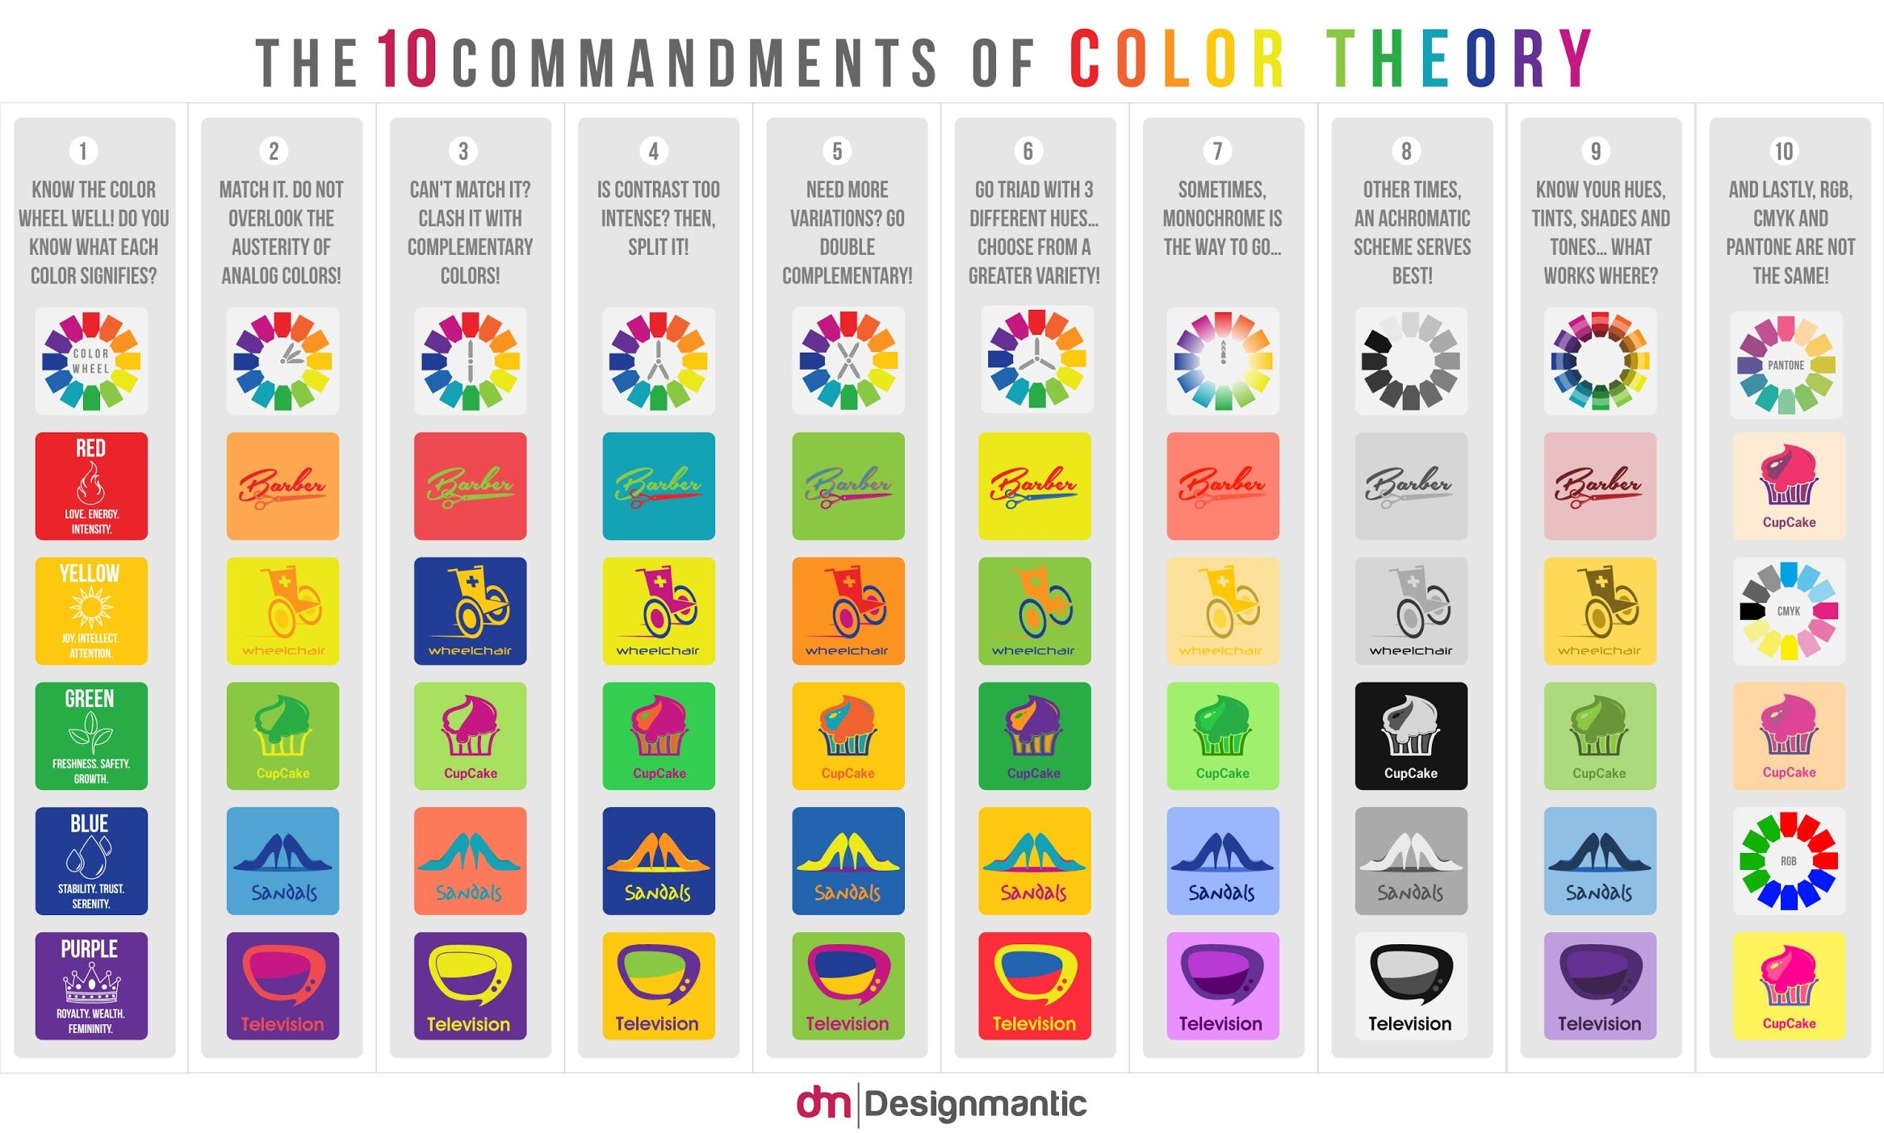

Introduction – **Typography**

**Guidelines:**

* Use **no more than 2–3 typefaces** (e.g., 1 for headings, 1 for body)
* Establish a **clear type of hierarchy** (H1 > H2 > Body > Caption)
* Use consistent **line height** (1.4x to 1.6x font size for readability)
* Choose web-safe and legible fonts (e.g., Inter, Roboto, Lato, Open Sans)

**Modifiers:**

* Weight (light, regular, bold)
* Case (uppercase for labels, sentence case for paragraphs)
* Letter spacing (for uppercase or small caps)

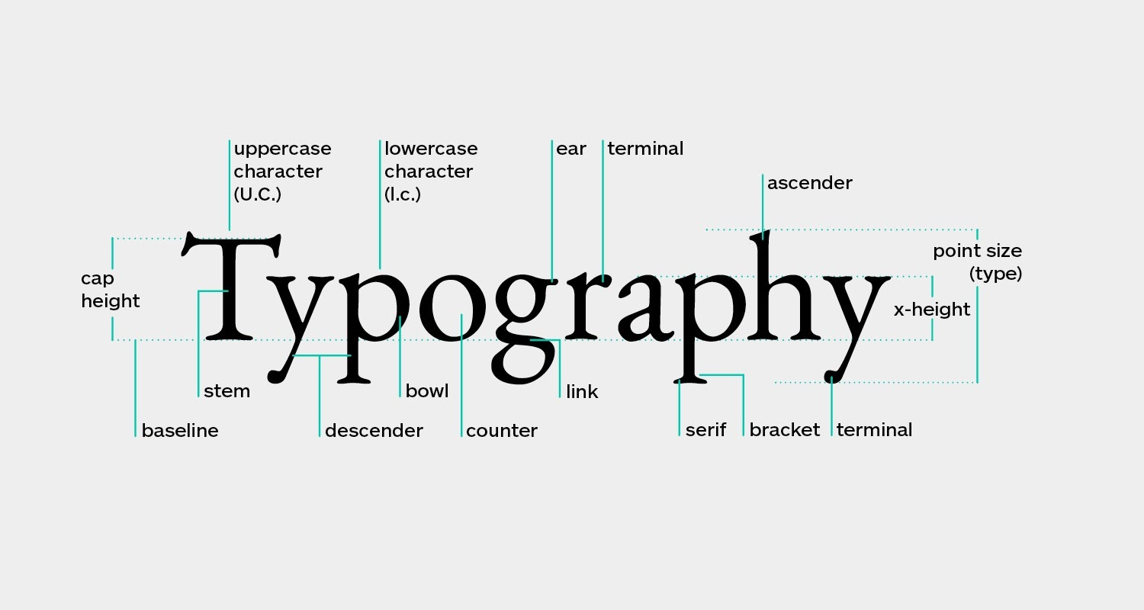

Introduction – **Accessibility**

**Core Practices:**

* Use sufficient **color contrast** (WCAG guidelines: 4.5:1 for body text)
* Add **alt text** to images
* Ensure **keyboard navigation** (tab order, skip links)
* Use **semantic HTML** for screen readers
* Don’t rely on color alone to convey meaning

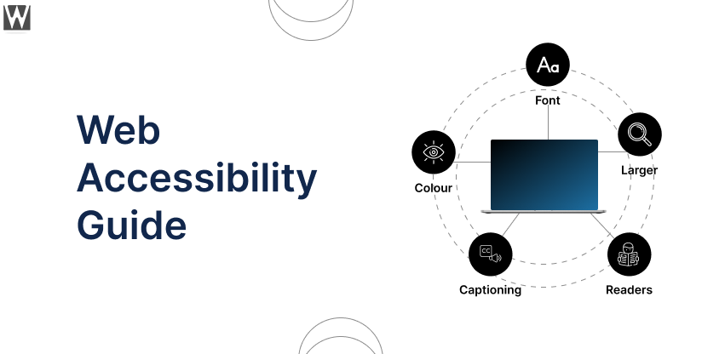

### 1. General Website

**Skeleton Page**

* Base layout with empty sections for content blocks
* Displayed while loading
* Helps establish spacing and structure

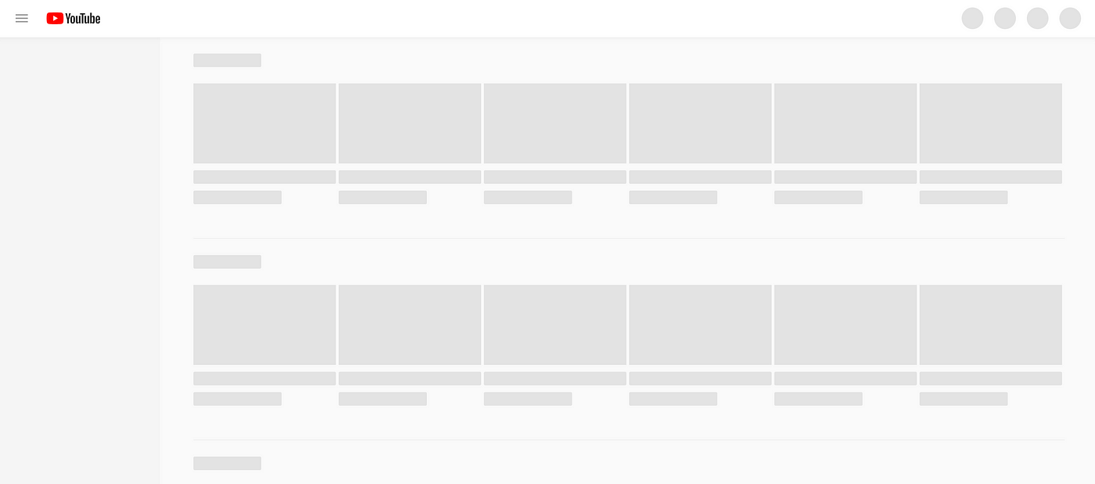

**Main Content**

* Dynamic portion of the page (text, images, interactivity)
* Usually inside a container or layout grid

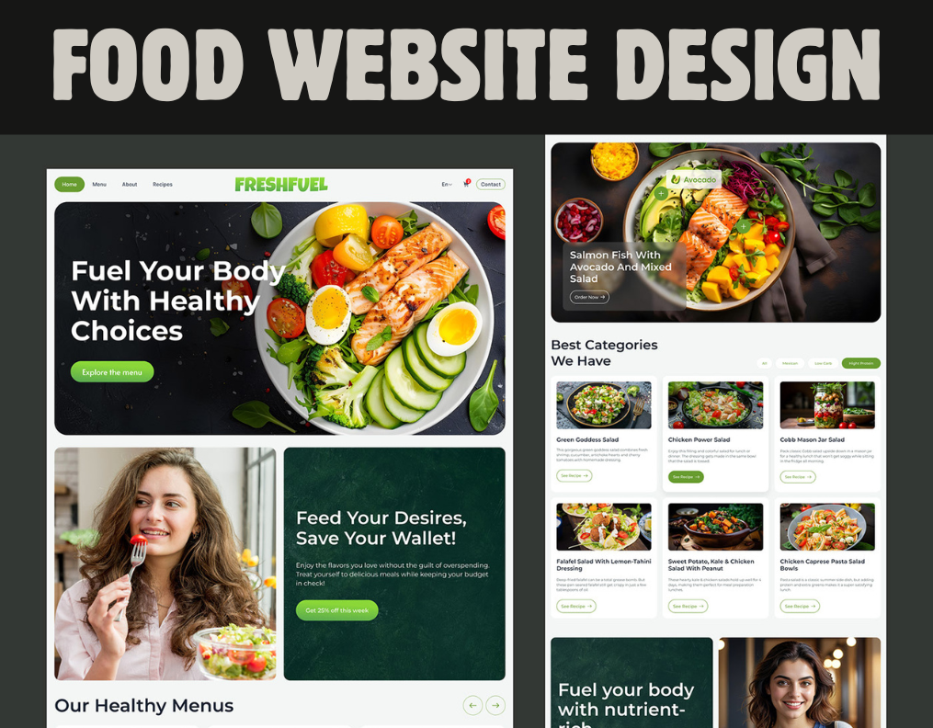

### 2. Navigation Elements

**Header**

* Consistent Element of the Website
* Holds all important Functions / Most used elements

**Sticky Header on Scroll**

* Nav bar / Header stays visible while scrolling
* Improves user access to nav and CTAs

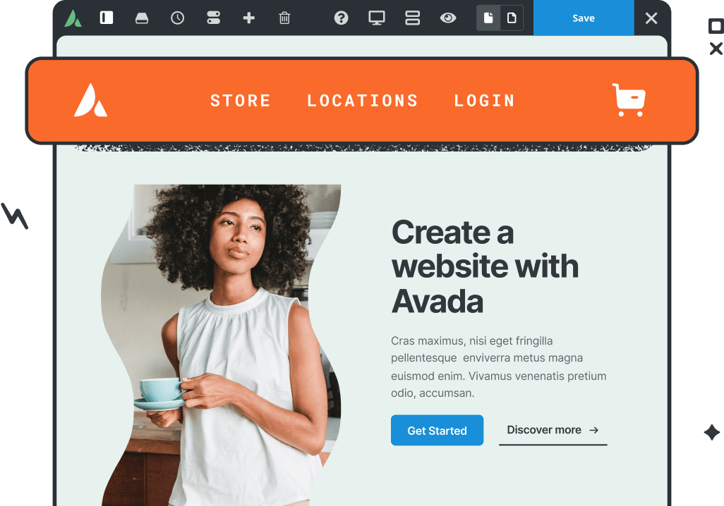

**Nav Bar / Menu**

* Fixed or scrollable navigation row
* Can include dropdowns, icons, and CTA button

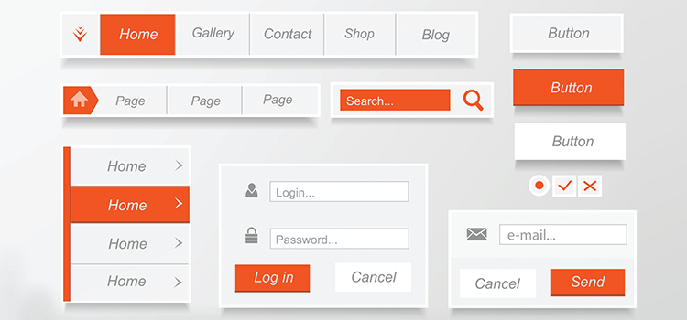

**Hamburger Menu**

* Collapsible icon (☰) used on mobile
* Toggles a slide-in or dropdown menu

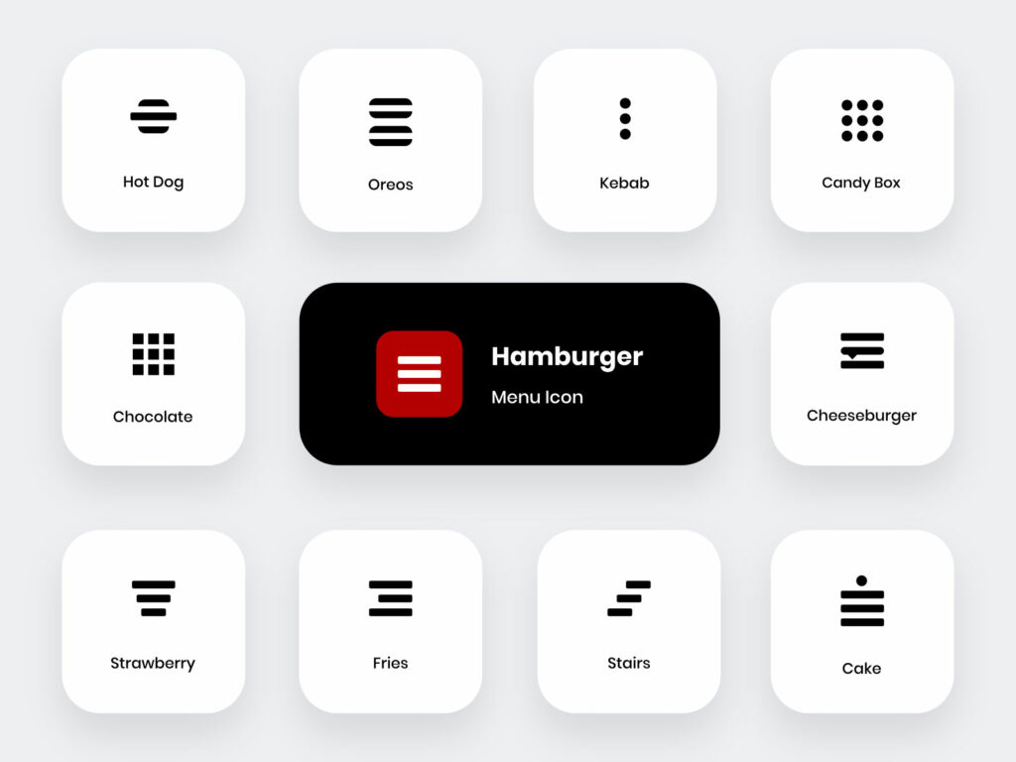

**Dropdown Menu**

* Expands on hover or click
* Nested nav for categories or multi-level links

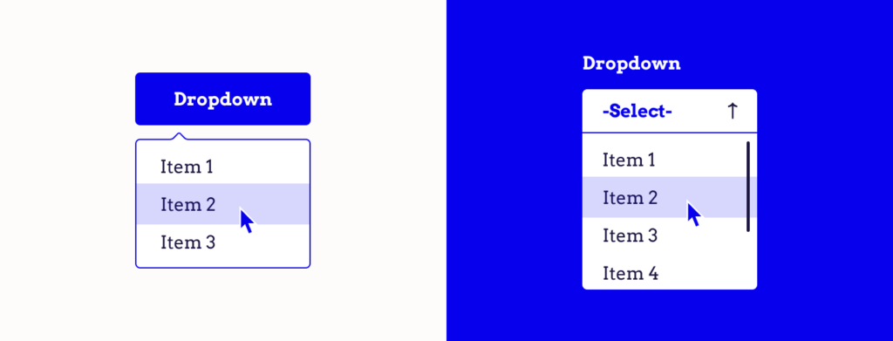

**Light/Dark Mode Switcher**

* Theme toggle (🌞 / 🌙 icons)
* Affects global color scheme

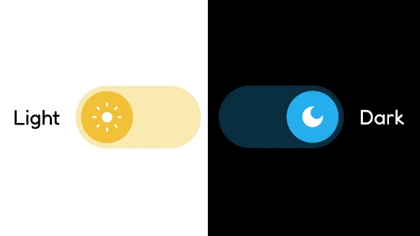

**Breadcrumbs**

* Show current page hierarchy (Home > Events > Schedule)
* Useful for deep pages or eCommerce

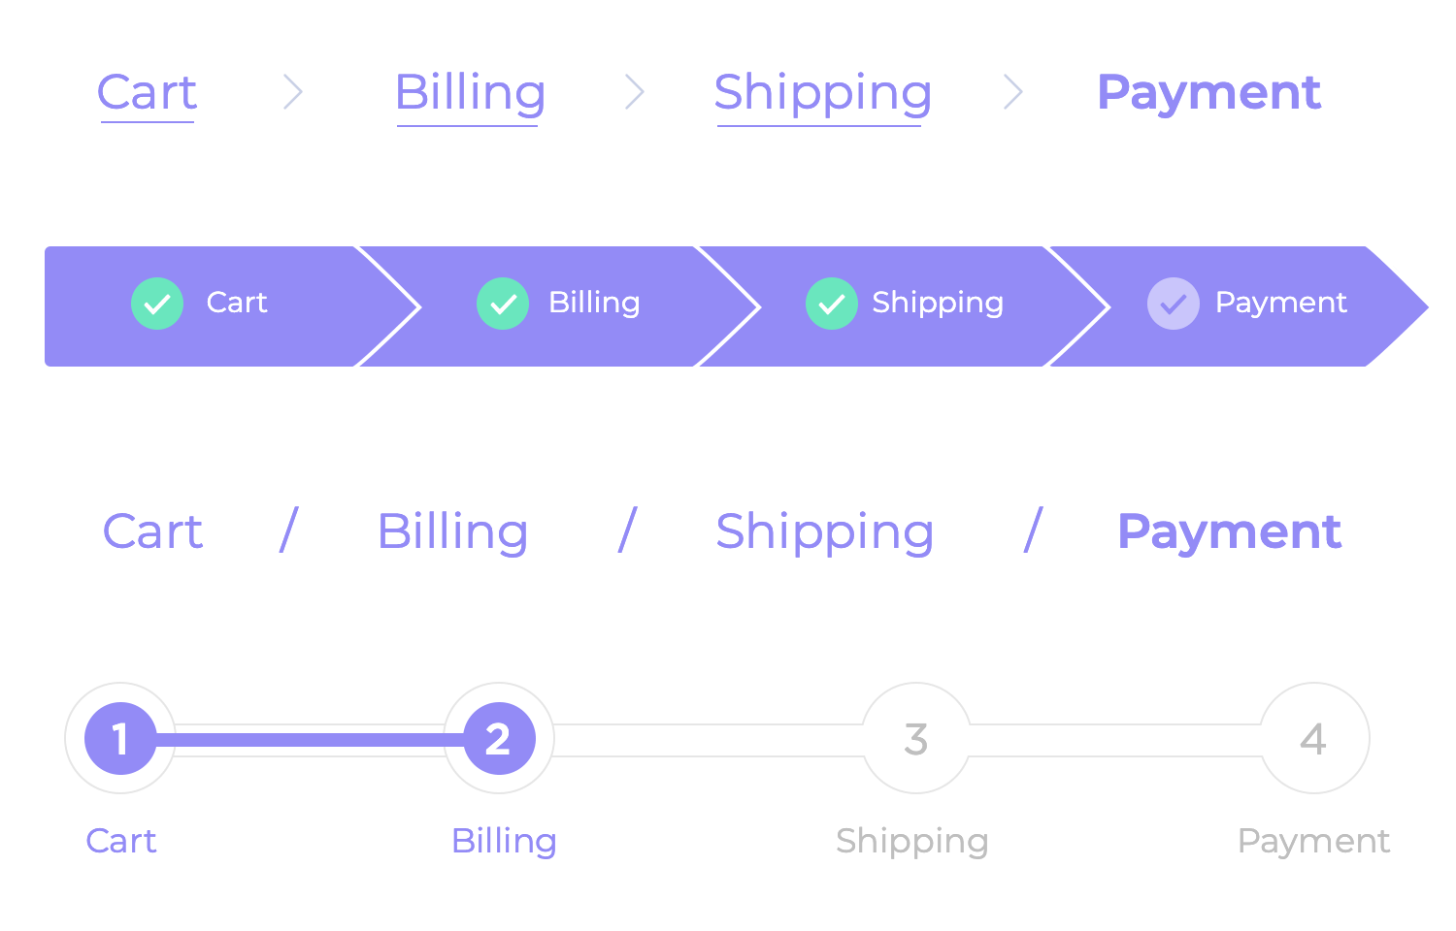

**Language Switcher**

* Toggle or dropdown to change language
* May use flag icons or language codes

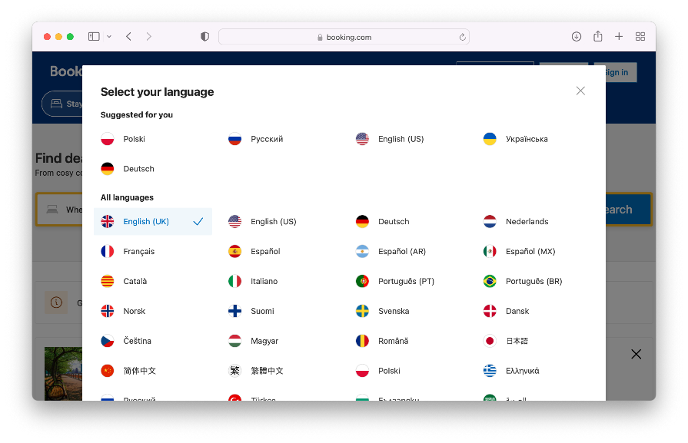

### 3. Hero Section Elements

**Includes:**

* Headline
* Subheadline
* Background image or video
* Overlay (darken background for contrast)
* CTA Button(s)
* Optional: Event Date, Tagline, Ratings, Logos

**Variations:**

* Fullscreen or half-screen
* With animation or parallax
* Minimal text or rich text combo

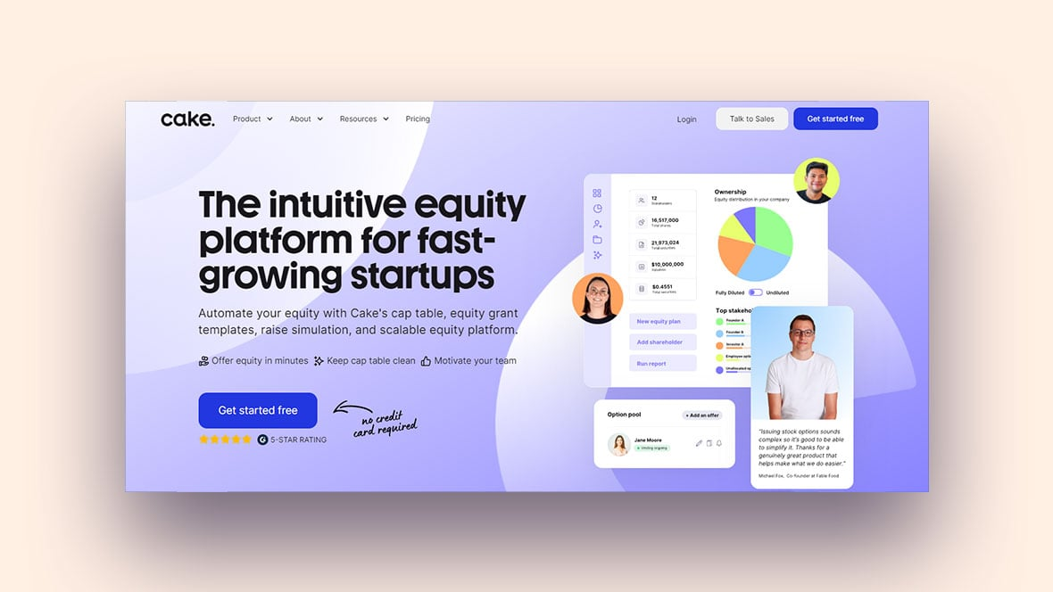

### 4. Cards

**Used For:**

* Displaying groups of content like blog posts, people, products

**Core Elements:**

* Image or icon
* Title & short description
* CTA (e.g., “Learn More”)

**Variations:**

* Vertical / horizontal layout
* Hover effects (lift, shadow, overlay)
* With tags, ratings, or icons

**States:**

* Default
* Hover
* Selected / Active

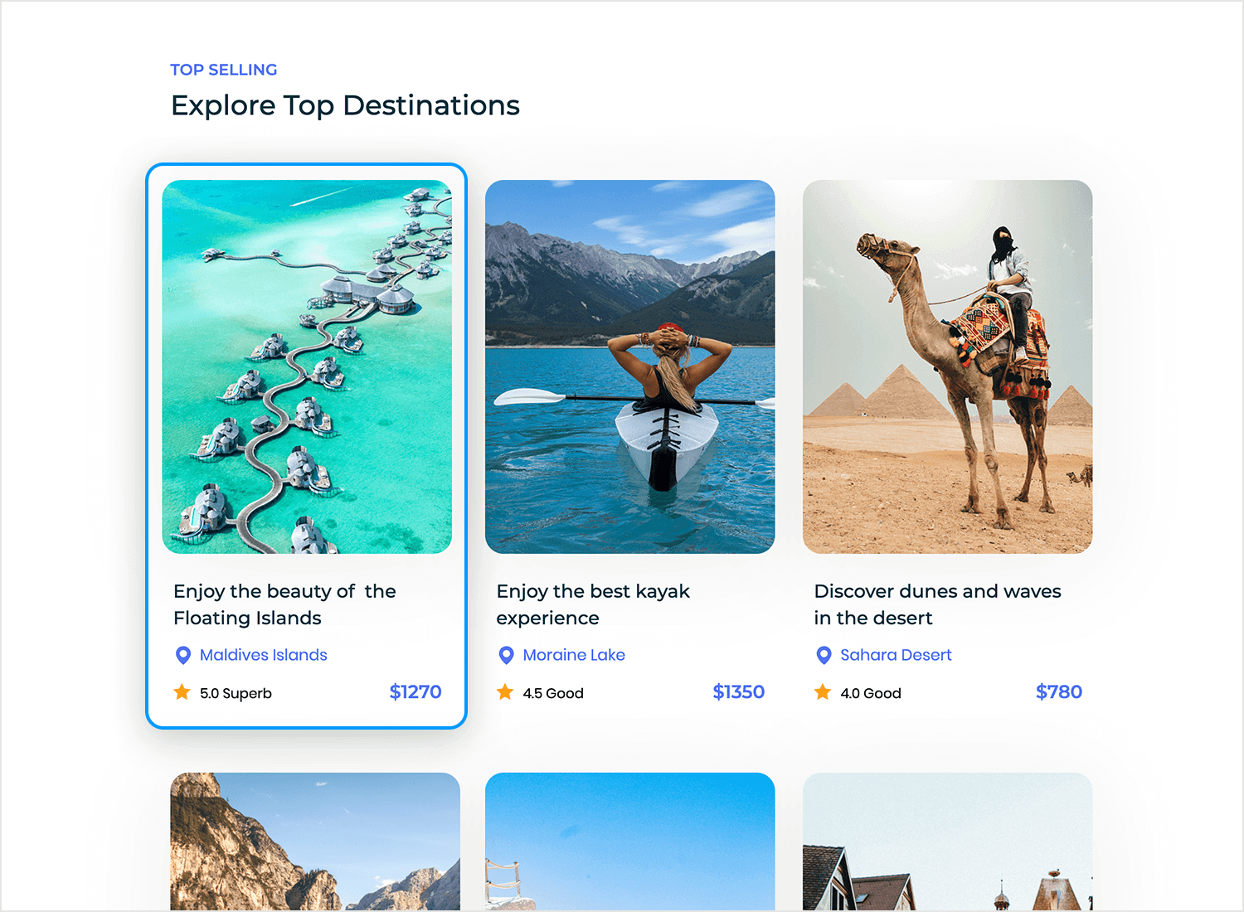

### 5. Section Blocks

**Definition:**

* Individual content areas used to divide a page

**Layouts:**

* 2-column (text & image)
* Full-width banner
* Alternating left/right images
* Grid or list view

**Modifiers:**

* Background (solid, image, gradient)
* Borders or separators
* Responsive stacking for mobile

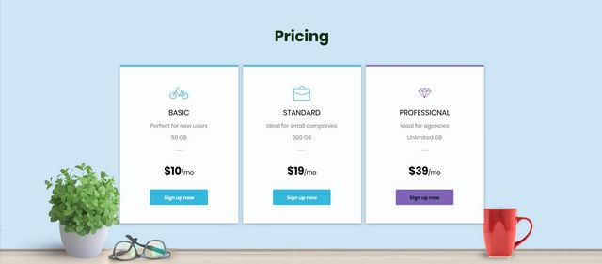

### 6. Forms

**Used For:**

* Contact, sign-up, ticketing, checkout, surveys

**Core Elements:**

* Input field
* Text area
* Dropdown
* Radio buttons / checkboxes
* Submit button

**States:**

* Empty
* Focused
* Filled
* Error (e.g., required)
* Success

**Modifiers:**

* Grouped inputs
* Inline validation
* Step-based (multi-page)

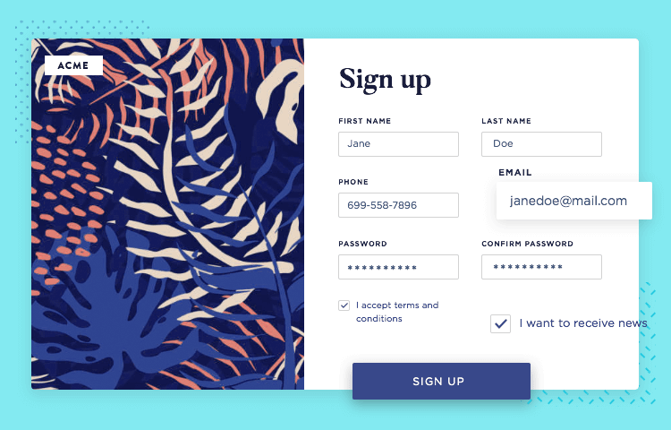

### 7. Event Schedule UI

**Used For:**

* Timed programs, agendas, conference schedules

**Components:**

* Time slots
* Event title & description
* Location
* “Add to calendar” buttons

**Layouts:**

* Tabs by day
* Accordion sections
* Vertical timeline
* Filters by type or category

**Modifiers:**

* Color-coded by type
* Searchable or filterable

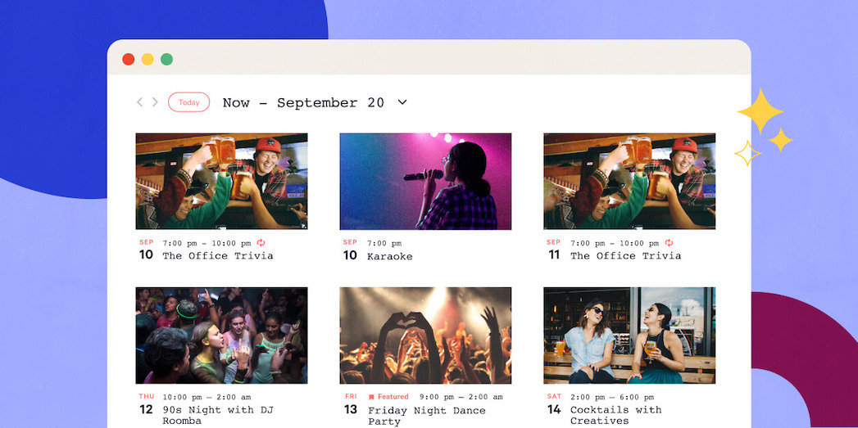

### 8. Interactive Elements

**Used For:**

* Adding interactivity and feedback

**Examples:**

* Scroll to anchor links
* Hover reveals / hover states
* Tooltips
* Accordions
* Modal windows (popups)
* Lightbox (image expand)
* Embedded maps or video
* Microinteractions (e.g., icon spin on hover)

**States:**

* Default
* Active
* Hovered
* Dismissed

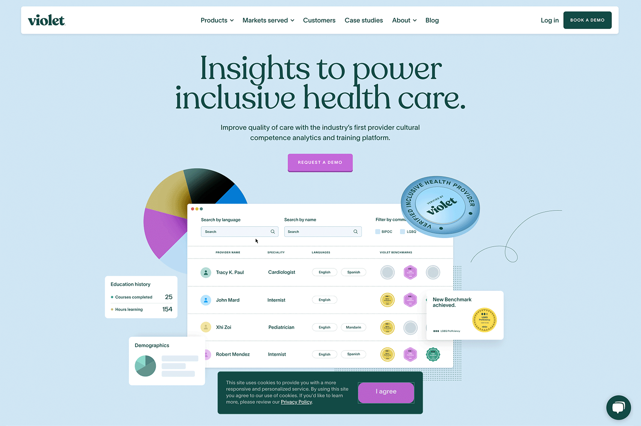

### 9. CTA Buttons (Call To Action)

**Purpose:**  
Encourages users to take a specific action

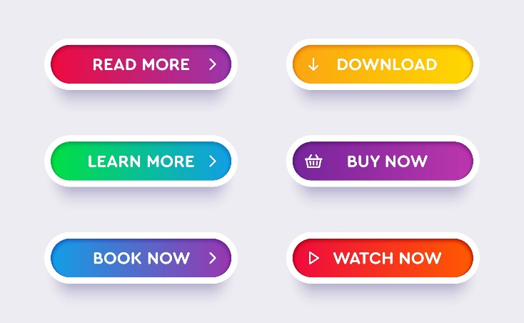**• Primary CTAs**

* Buy Tickets
* Reserve Now
* Get Started
* Sign Up Free
* Learn More

**• Secondary CTAs**

* Contact Us
* Watch Video
* 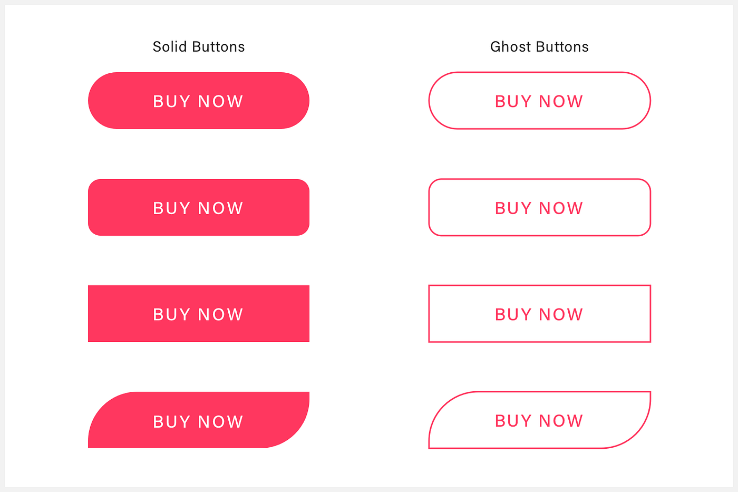View More
* Subscribe
* See Schedule

**• States**

* Default
* Hover
* Pressed / Active
* Disabled
* Loading

**• Modifiers**

* With icons (e.g., arrows, plus)
* Ghost button (transparent background, border)
* Full-width (for mobile or emphasis)
* Outlined vs. filled

### 10. Media UI

**Used For:**

* Displaying photos, videos, and social content

**Components:**

* Image gallery / carousel
* Embedded videos (YouTube, Vimeo)
* Lightbox preview
* Auto-play or manual controls
* Social media previews (Instagram feed, Twitter embed)

**Modifiers:**

* Grid layout
* Caption overlay
* Pagination / navigation arrows

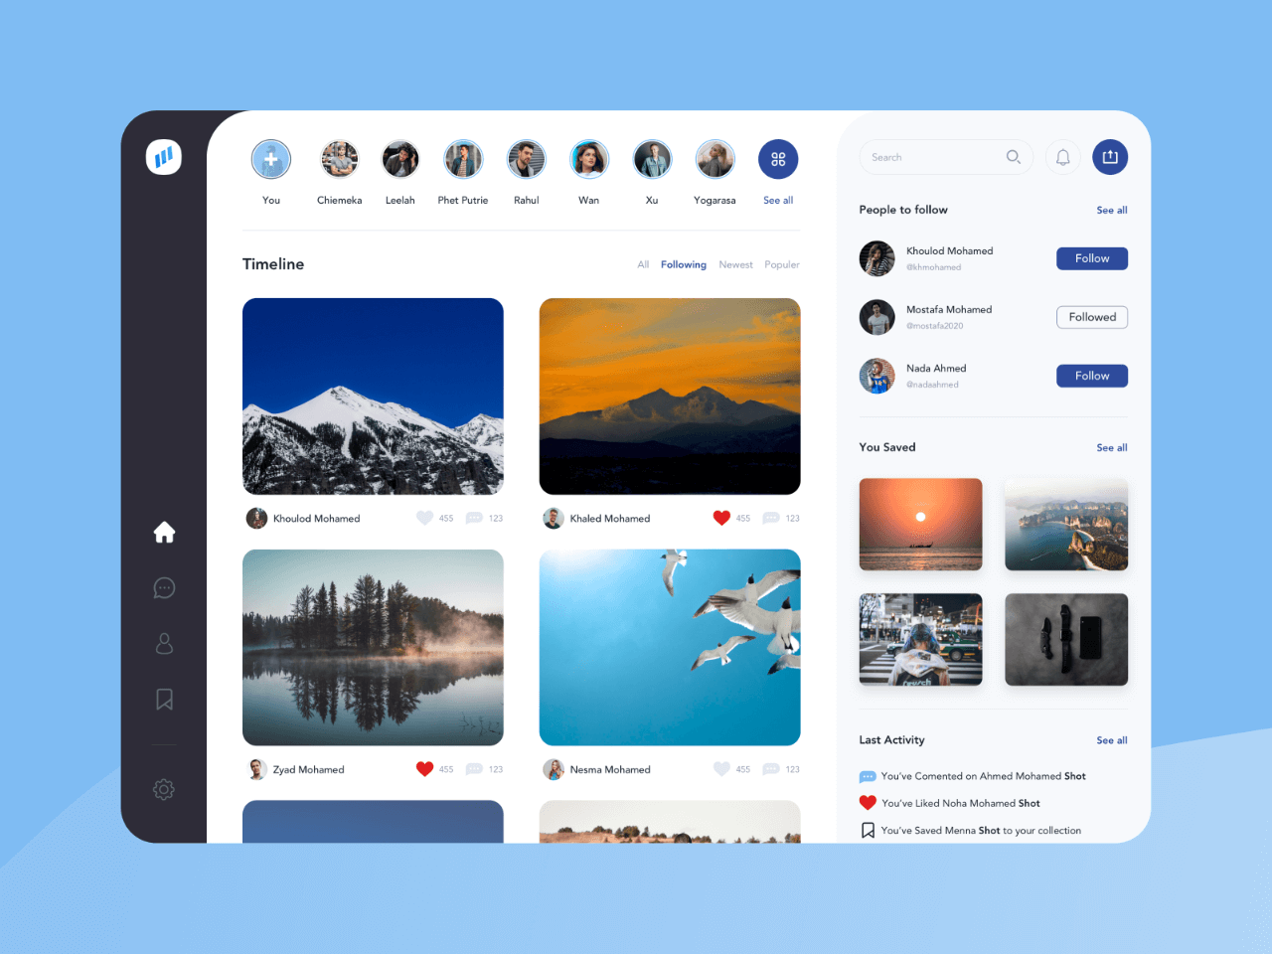

### 11. Footer UI Elements

**Purpose:**  
Secondary navigation and site utility

**Common Elements:**

* Logo
* Quick links (About, Contact, FAQ)
* Newsletter signup
* Social media icons
* Legal links (Privacy Policy, Terms)
* Contact info (email, phone, address)

**Modifiers:**

* Multi-column layout
* Minimal / condensed for mobile
* Optional back-to-top button

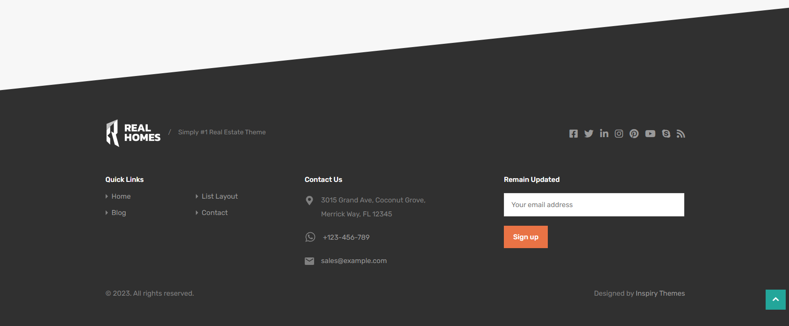

### 12. Supporting Components

**Used Throughout Website**

* Tags / Badges (e.g., “New”, “Popular”)
* Chips (selectable or filterable pills)
* Toasts / Notifications (temporary alerts)
* Accordions / Collapsibles
* Tabs
* Tooltips
* Pagination
* Progress bars / steps
* Rating stars

**States:**

* Default
* Hover
* Active
* Dismissed

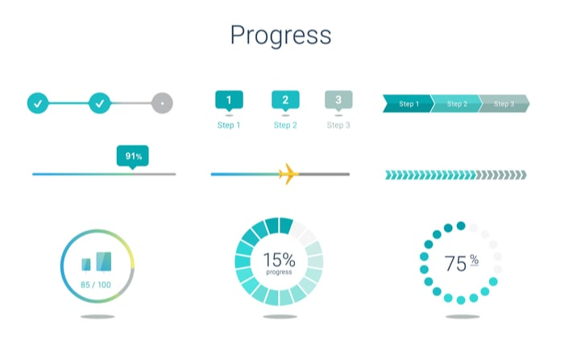

### 13. Typography / Icons

**Typography:**

* Heading hierarchy (H1 > H2 > H3 > Body)
* Font pairings (Display + Body font)
* Line height and spacing
* Uppercase / lowercase
* Weight variety (regular, bold, light)

**Icons:**

* Functional icons (search, menu, close)
* Status icons (checkmark, warning, error)
* Decorative icons (for categories or sections)
* Icon sets (Font Awesome, Iconify, Material Icons)

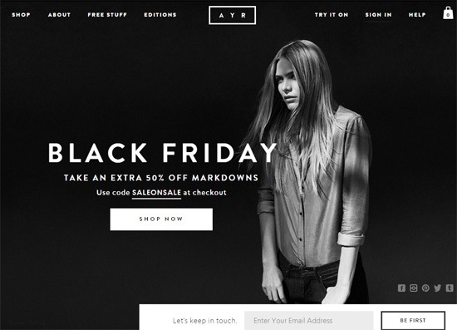

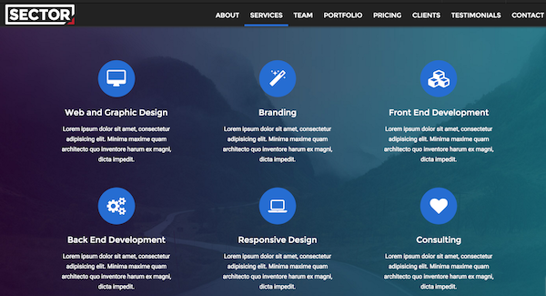

### 14. UX Patterns

**Reusable patterns for common flows:**

* Empty States
* Toast vs. Modal vs. Inline Error
* Multi-Step Forms / Wizards
* Onboarding Tours
* Confirmation Dialogs
* Pagination vs. Infinite Scroll
* Filtering & Sorting

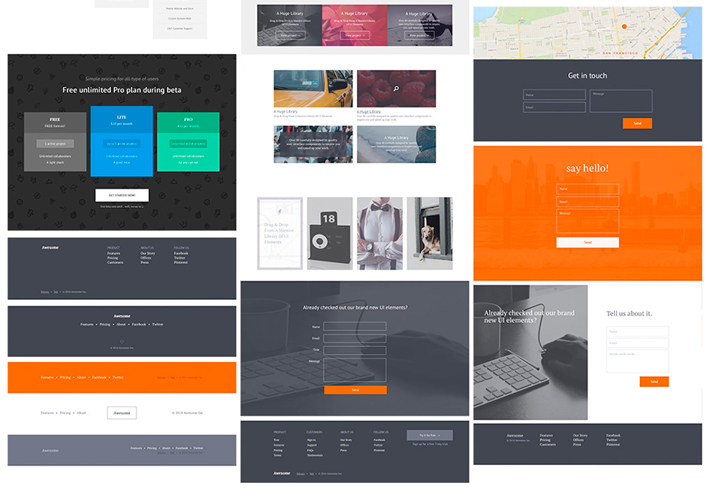

### 15. Design Tokens / Foundations

**For scalable design systems:**

* **Color Tokens**: --color-primary
* **Spacing Tokens**: --space-sm, --space-lg
* **Font Tokens**: --font-body, --font-display
* **Border Radius**: Rounded levels (sm, md, full)
* **Elevation Levels**: Shadows / z-index

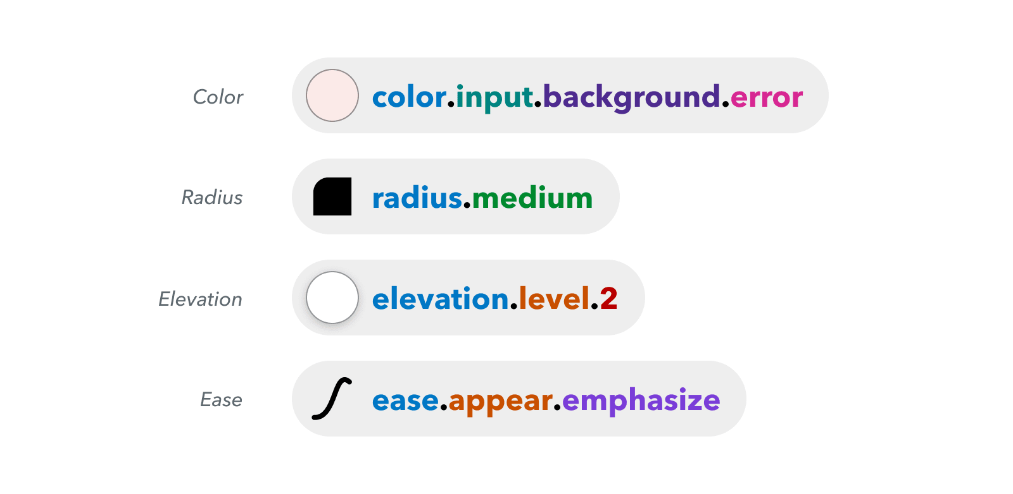

### 16. User Journey & Flow Mapping

**Define user behavior and interaction paths:**

* Landing → Explore → Sign Up → Convert
* Key touchpoints: CTA clicks, scrolls, form submissions
* Tools: Flowcharts, wireframes, journey maps
* Use in onboarding, checkout, lead generation

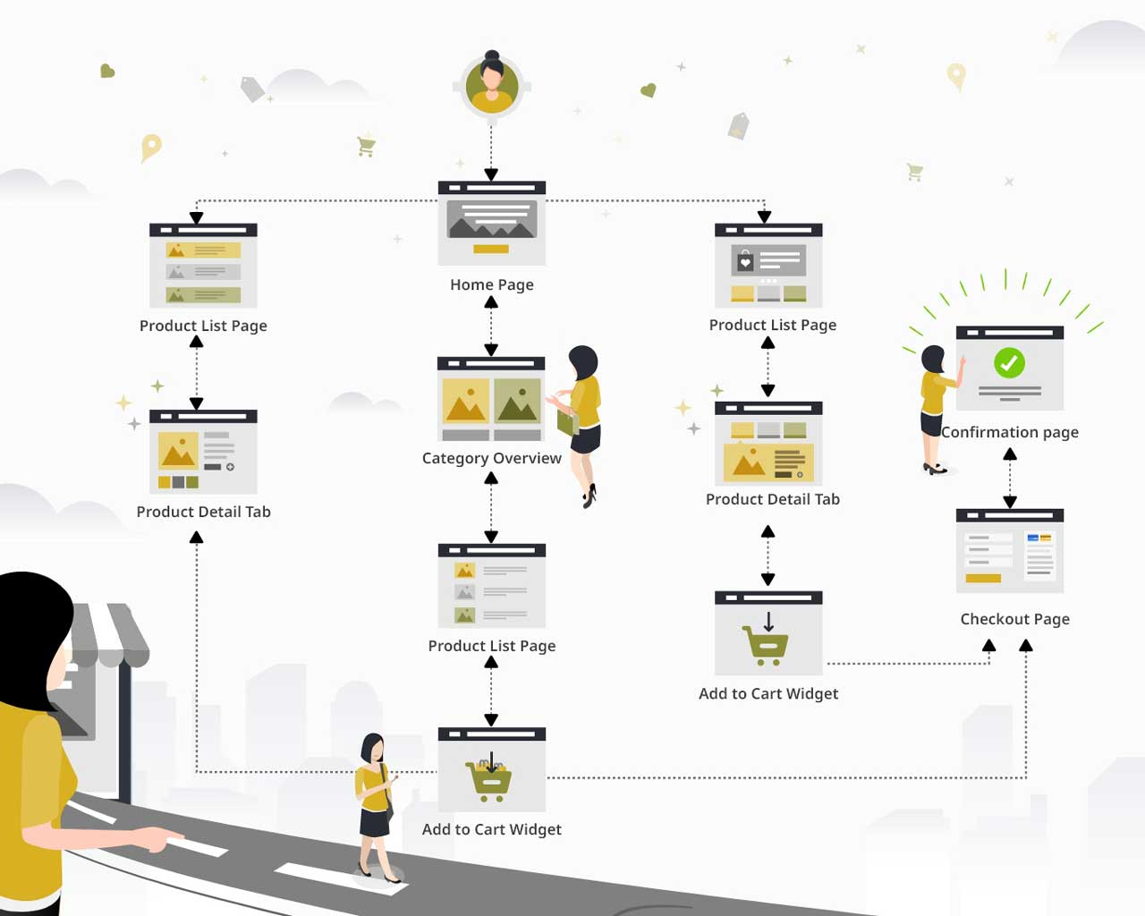

### 17. Layouts

**Grid Systems**

* 12-column (common for web)
* 4, 6, or 8-column (for mobile or tighter designs)
* Vertical spacing grid (4pt, 8pt, 10pt systems)
* Baseline grid for consistent text alignment

**Breakpoints (Responsive Design)**

* Mobile: ≤ 480px
* Tablet: 481px–768px
* Small Desktop: 769px–1024px
* Large Desktop: 1025px+
* Custom breakpoints for high-res or ultrawide displays

**Containers**

* Fixed-width (e.g., 1140px or 1280px)
* Fluid containers (percentage-based)
* Max-width constraints to limit stretch

**Spacing System**

* Consistent paddings/margins (4, 8, 16, 24, 32 px...)
* Token-based spacing (e.g., --space-md)
* Internal spacing vs. external spacing

**Flex & Auto Layout (Figma / CSS)**

* Direction: horizontal / vertical
* Justify: start, center, end, space-between
* Align items: top, center, bottom
* Wrap content for responsiveness
* Stack items with spacing in between

**Z-Index Layers (Stacking Context)**

* Base layer: content
* Middle: overlays, cards
* Top: modals, tooltips, navbars

**Column-Based Layouts**

* Single column (mobile, blog post)
* Two-column (content + sidebar)
* Three-column (dashboard UI)
* Masonry (Pinterest-style grid)

**Common Page Structures**

* Header → Hero → Content Blocks → Footer
* Hero → Features → Testimonials → Pricing → CTA
* Sidebar Layout (e.g., docs, dashboards)
* Tabbed Interface (horizontal or vertical tabs)

**Alignment & Positioning**

* Centered layout (login pages, modals)
* Left-aligned for readability
* Split-screen (image left, text right)
* Floating elements (badges, tooltips)

**Visual Hierarchy Techniques**

* Size (larger = more important)
* Color contrast (draw attention)
* Spacing (grouping related content)
* Typography hierarchy

**Section Transitions**

* Hard cut (clear block separation)
* Soft transition (gradients, curved dividers, slants)
* Overlapping sections (for depth and flow)

**Mobile-First Principles**

* Stack content vertically
* Touch-friendly tap targets
* Collapse complex structures (e.g., accordions, tabs)

**Layout Patterns**

* F-pattern (reading left to right, top to bottom)
* Z-pattern (used in landing pages)
* Card-based layout (modular, responsive)
* Scrollable horizontal layout (e.g., product carousels)

**Modifiers:**

* Full width vs. constrained
* Sticky sections (e.g., sidebar, headers)
* Nested layouts (e.g., cards within grids)
* Responsive visibility (show/hide by device)

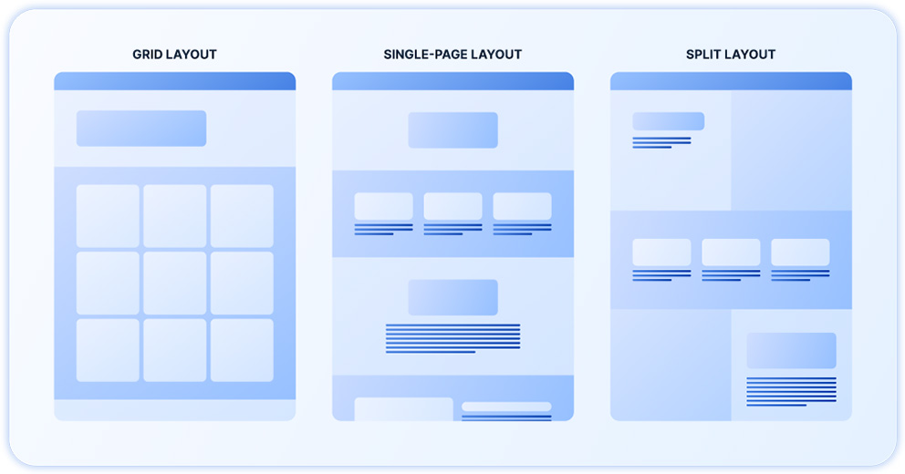

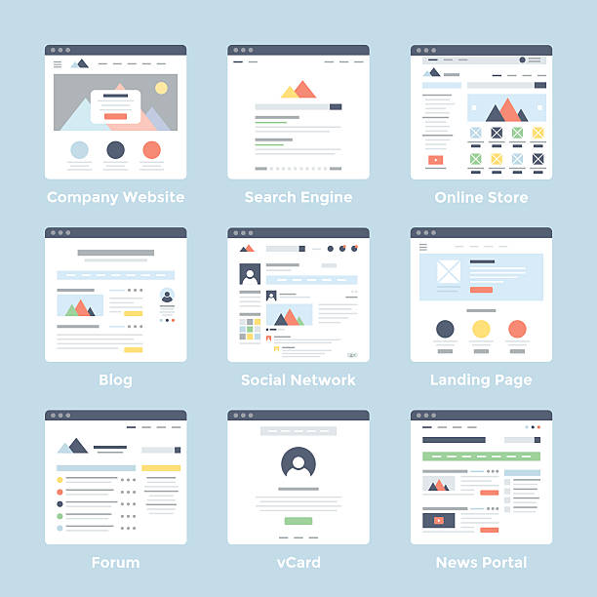

**Picture Sources:**

<https://www.flaticon.com/de/kostenloses-icon/website-design_5234318>

<https://red-website-design.co.uk/design-principles-effective-website/>

<https://www.geeksforgeeks.org/principles-of-web-design/>

<https://www.wix.com/blog/7-principles-of-design-websites>

<https://uxplanet.org/7-essential-principles-of-web-design-e9645d54cec8>

<https://www.hongkiat.com/blog/basics-behind-color-theory-for-web-designer/>

<https://www.designmantic.com/blog/infographics/the-10-commandments-of-color-theory/>

<https://www.flux-academy.com/blog/what-is-typography>

<https://www.webyking.com/blog/web-accessibility/>

<https://uxdesign.cc/what-you-should-know-about-skeleton-screens-a820c45a571a>

<https://www.designerpeople.com/blog/food-website-design/>

<https://avada.com/feature/header-builder/>

<https://amazing7.com/navigation-bar-why-it-holds-importance-for-a-website.html>

<https://www.webdesign-journal.de/hamburger-menue/>

<https://www.a11y-collective.com/blog/mastering-web-accessibility-making-drop-down-menus-user-friendly/>

<https://www.youtube.com/watch?v=YpV3FUswUks>

<https://www.justinmind.com/ui-design/breadcrumb-website-examples>

<https://simplelocalize.io/blog/posts/ui-design-language-selector-examples/>

<https://www.sliderrevolution.com/design/what-is-a-hero-section/>

<https://www.justinmind.com/de/ui-design/karten>

<https://blog.duda.co/sections-new-building-blocks-modern-web-design>

<https://medium.com/uxparadise/guidelines-for-awesome-web-form-design-f1ebbf122d9>

<https://theeventscalendar.com/blog/learning/best-way-to-display-events-on-your-website/>

<https://www.justinmind.com/blog/interactive-website-designs-youll-want-to-steal/>

<https://www.bigdcreative.com/5-tips-for-designing-a-call-to-action-button-that-converts/>

<https://masteryourwebsite.com/design-call-to-action-button-c87446a65949>

<https://sketchelements.com/tag/social-media/>

<https://realhomes.io/footer-layouts/>

<https://brunch.co.kr/@mobiinside/4911>

<https://www.webfx.com/blog/web-design/web-typography-examples/>

<https://sonysimon.com/web-development/icon-usage/>

<https://www.awwwards.com/mastering-ui-patterns-for-smarter-design.html>

<https://smart-interface-design-patterns.com/articles/naming-design-tokens/>

<https://www.softcrylic.com/blogs/understanding-user-journey-maps-in-digital-marketing/>

<https://ventraip.com.au/blog/website-layout-ideas/>

<https://www.istockphoto.com/de/search/2/image-film?phrase=website+layout>